**Definition**

Google Analytics 4 (GA4) events is when a user interacts with content on a website or an app, where each action will be recorded as an event (Kiblitskyi, 2023). Examples of events include clicking a link, scrolling through a webpage, or navigating to different pages within the site (Petrosyan, 2023). GA4 will capture every interaction and provide a detailed view of how users engage with site content (Kiblitskyi, 2023).

**Function and Role**

Events in Google Analytics 4 (GA4) are important for check how users interact with a website. They help check specific actions users take, allowing website owners to see if the website is optimized properly with relevant content and well designed site. By checking these events, website owners can see where improvements are needed. By analysing these events, businesses can better understand user behaviour and make their websites more optimized by modifying content effectively and other engagement methods which would increase conversion rate of users.

**Event Properties**

Event properties in Google Analytics 4 are details that describe more about each user event. These properties consist of:

1. Event Name: Identifies the type of user interaction, like when someone plays a video, page_view or a purchase is being made.
2. Event Parameters: Additional details about an event, such as video duration or currency.
3. Event Value: Numeric measure of an event, such as a amount for purchase.
4. User Properties: Characteristics that describe users, like location or gender, to segment data.

**Events from my microsite Dhee microsite (**[**https://sites.google.com/iit.ac.lk/musicbydhee/home**](https://sites.google.com/iit.ac.lk/musicbydhee/home) **)**

**Page views** - This is an event which tracks every time a page is viewed in the stie. When someone views any of the site’s pages such as home or contact page (reference) it will be counted as this. This data is crucial for understanding traffic distribution across the site, identifying the most popular pages.

**First visit** - This property is when new a user is visiting the site for the first time. Tracking first visits can help understand how many new users are attracted to the site after specific marketing campaigns.

**Clicks** – This event tracks the interactions when a user clicks on something on the site like internal and external links, and buttons. When a user clicks any of the links or buttons that is attached such as navigation of the site (reference) or external links to other sites (Reference). The conversion rate and the effectiveness of calls to action can be analysed by checking this event.



**Form Submission**: When a user fills the form and submits the form by clicking on the submit button will count as event. The contact page in the microsite has a form (Reference). The conversion rate and the effectiveness of calls to action can be analysed by checking this event.

**Video Play**: Monitoring video plays on site (reference) as events collects important information on user engagement, including the number of viewers, viewing duration, and when they pause or stop watching. This data is important for analysing the effectiveness of video content and if it useful for the user.

**Task 2 Creating Google Analytics account and linking it to the microsite**

**Steps:**

1. Visit the Google Analytics website and sign in with your Google account. If you don’t have one, you will need to create it.
2. Start the Setup Process by clicking on the "Start measuring" button to set up a new account.
3. After setting up a new account, fill and set up a property account. Select suitable options based on your location and business. Mention your business size and what you want to track.
4. Once your property is created, go to the "Data Streams" (refer figure section 1) section from the “Admin” portal.



1. A screenshot of a computer

   Description automatically generatedSelect "Web" (refer figure section 1) to add your microsite.



1. A screenshot of a computer

   Description automatically generatedEnter your microsite’s URL and a stream name (refer figure section 1 and click on "Create stream" (refer figure section 2).
2. A black square with red border

   Description automatically generatedA screenshot of a computer

   Description automatically generated Copy the “Measurement ID” code (refer figure section 1)
3. Go to your google site and go to “Analytics” on under the setting (refer figure section 1) and paste the measurement ID (refer figure section 2)

1. Toggle “Enable Analytics” on (refer figure section 3) and this will enable the analytics for your site.

Task 3

3.1 HTTP Cookie

HTTP cookies are small data files that a website sends and a user's web browser stores while browsing (Lee *et al.*, 2019). These cookies are designed for websites to remember information such as items added in the shopping cart in an online store or to record the user's browsing activity such as button clicks, login details, or the history of pages visited (Shanley, n.d).

3.2 HTTP Cookies solving the problem of stateless web.

The stateless of the HTTP protocol, each client-server request is treated as separate and independent. The servers can’t identify past requests and cannot tell if consecutive requests come from the same user. Basically each request would be treated as a new request, basically making it difficult to track users previous interactions (Wolf and Henley, 2017).

Cookies primarily address the stateless web issue by maintaining user sessions by storing specific information such as login credentials and preferences (Yazar, n.d). Cookies store data on the user’s device which can later be retrieved for example information like your name, email, or items you have added to a cart in an ecommerce site. This can allow servers to remember these details across multiple requests. This would allow websites to offer personalized settings and customized experiences to users (Moskowitz, 2023).

**3.3 Limitation of cookies**

* Storage Limitations - Cookies have a storage limitation, where each cookie can store only up to 4KB of data. There is also a limit on the number of cookies that can be stored in each domain (Kontotasiou, 2022).
* Privacy Concerns: Cookies can create privacy concerns because they collect and store details about user actions and preferences. This information could be accessed by third parties without the user's permission, leading to privacy violations (Calzavara et al., 2018).
* Expiration Issues: Cookies have expiration settings that can lead to the loss of important data if not configured correctly. This can be a limitation since it can lead to loss of useful data if not set properly and resulting to poor user experience when they revisit (Strycharz *et al.*, 2021).
* Security issue: Cookies are exposed to security breaches, leading to unauthorized access through methods like cross-site scripting (XSS) and cross-site request forgery (CSRF) (Putthacharoen and Bunyatnoparat, 2011). If cookies are not properly secured, these vulnerabilities can result in significant risks such as session hijacking and steal sensitive data (Pauli, 2013).

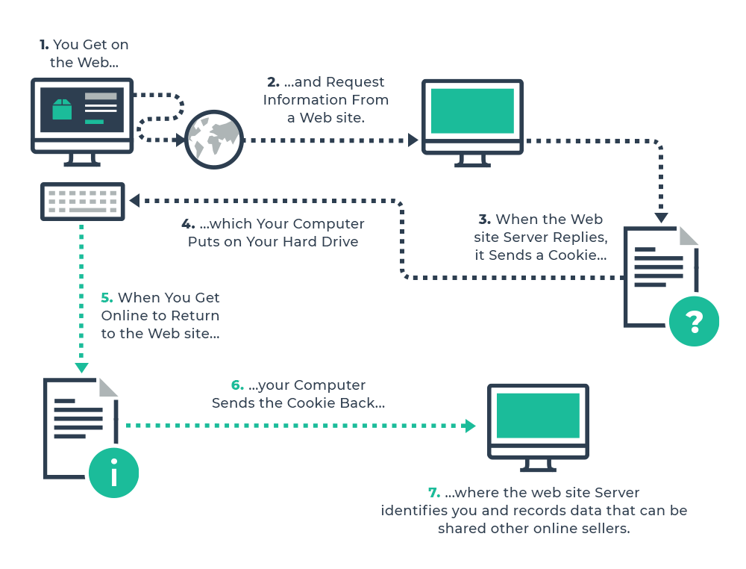**Diagram**

High-level description of how cookies work. Source: Pixel Privacy, 2019 (Pixel Privacy, 2019).

The diagram above shows the process of a cookie during a web session. It starts with when a user accesses a website, their browser asks for information from the site's server. The server responds by sending a cookie, which is saved on the user's computer. When the user revisits that website, their browser sends the cookie back to the server, allowing it to identify the user, personalize the session, and possibly provide this information to other websites or applications (arvindpdmn, 2020).

**Task 4**

The microsite was shared for five consecutive days (9th April 2024 to 13th April 2024) and the results gathered from the reports are shown below.

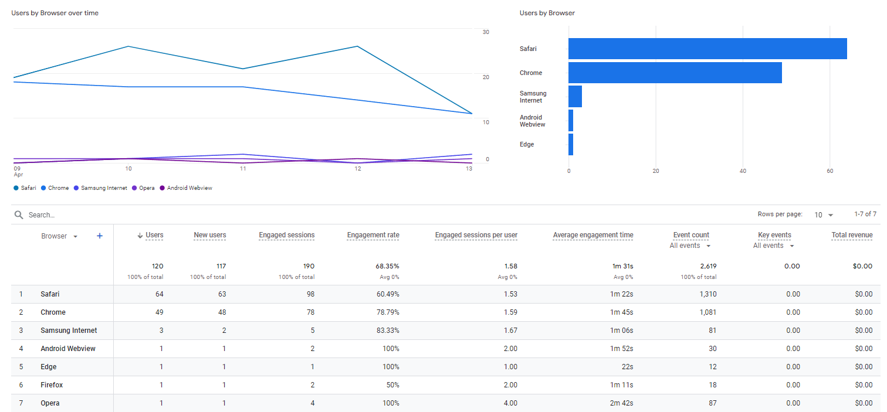4.1 Report 1 – **Users by browser over time**

The report indicates the variety of browsers that visitors used to access the site. It reveals that Safari was the common browser, with 64 users accessing the microsite from it, followed by Chrome with 49 users. Opera was the least accessed browser to visit the microsite, with only a single user recorded as having used it to visit the site.

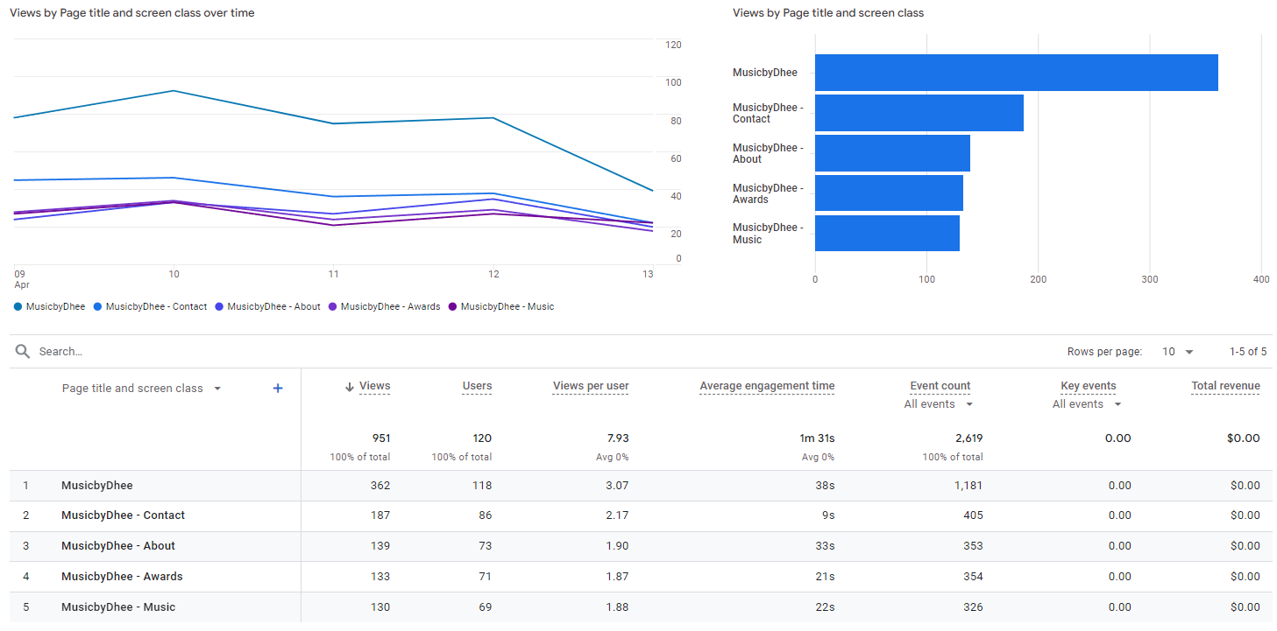4.2 Report 2 – Views by Page title and screen class over time

The report provides the number of visits of each page of the website by users and by various screen sizes. According to the data shown, the website got a total of 951 views from 120 users. The most frequently visited page was the "MusicbyDhee" page, attracting 362 views. The second most visited was the "MusicbyDhee – Contact" page, with 187 views. The "MusicbyDhee – Music" page received the fewest views within the microsite, totalling 130.

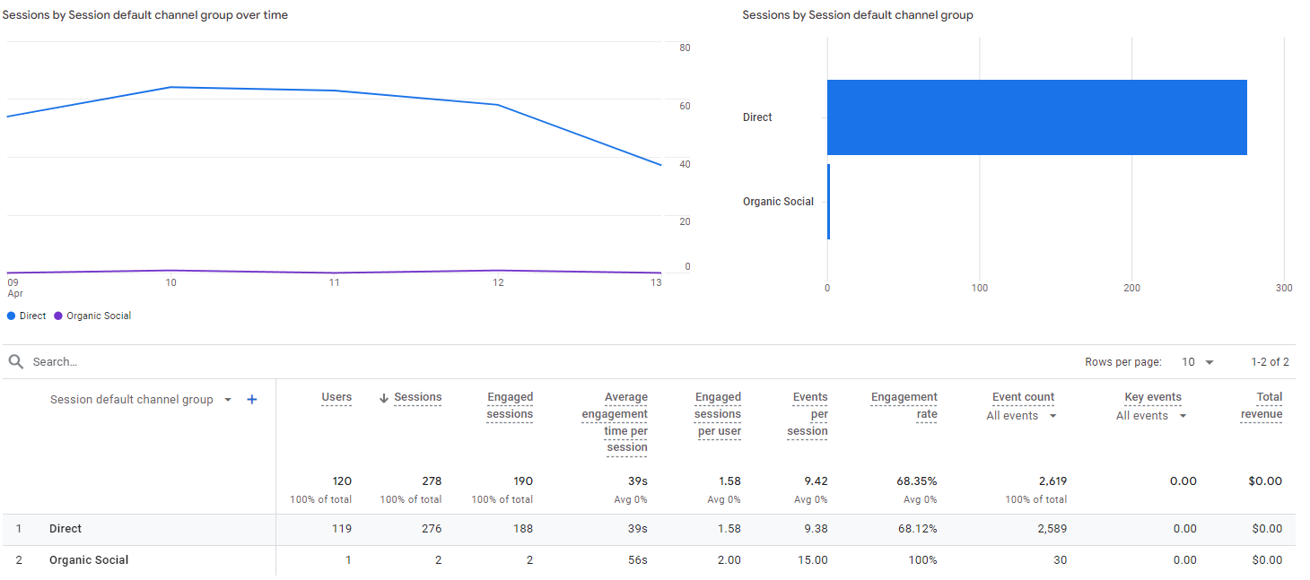4.3 Report 3 – Sessions by ‘session default channel grouping’

This report shows the distribution of sessions by default channel groupings, listing the sources through which users accessed the microsite. According to report, there were two sources, direct and organic social. Out of 278 sessions, 276 sessions were from directly typing or pasting URL to visit the site and only 2 were organic social. This indicates that social media marketing should be taken place to increase sessions from organic social channel.

4.4 Report 4 - New users by ‘First user default channel grouping’

This report shows the channels through which new users accessed the microsite. Out of 117 new users, nearly all arrived by directly copying and pasting the link or typing the URL into their browser. Only one user came through organic social media channels. This data indicates that social media marketing strategies need to be done to increase the number of users discovering the site through these platforms.

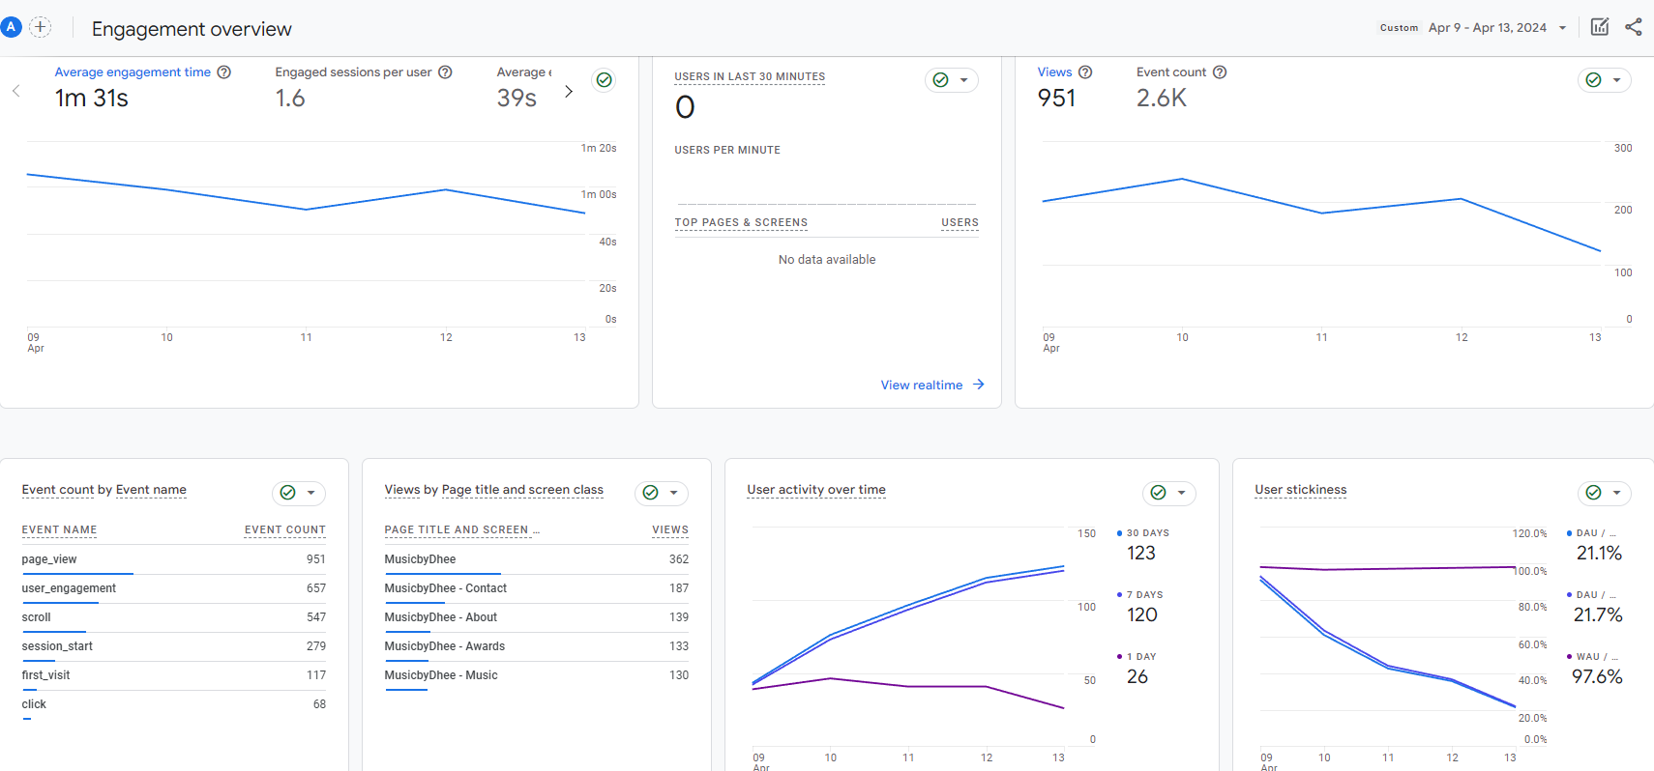4.5 Report 5 - User Engagement (overview)

The report offers an overview of user engagement on the website. It shows the average engagement time per user, which stands at 1 minute and 31 seconds and the engaged session by user is 1.6. It is shown in the diagram that throughout the 5-day period, the user engagement time was dropping. Additionally, the report outlines the total number of page views and tracks user activity over a specified period.

4.6 Report 6 – User Retention (overview)

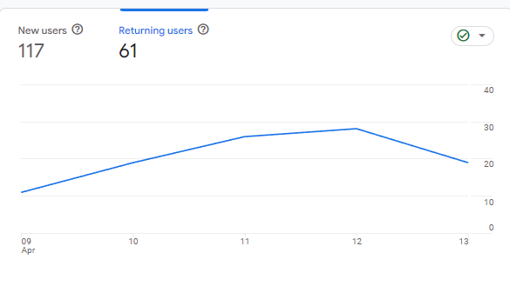

The report shows the difference between new and returning users to the site. It indicates that there were 117 new users. Additionally, data suggest that there was a significant user retention, with 61 users returning to the site, meaning that approximately half of the users revisited. As showed in the diagram (refer to figure section 1), there is a trend showing an increase in the number of returning users, while new users are on the decline (refer to figure).

4.7 Report 7 - Users by City

The report provides information on the geographical distribution of the site's visitors, showing the cities from which users accessed the microsite. It reveals that most users visited from Colombo, totalling 79, followed by Weligama with 18 users, proving majority of users are from Sri Lanka. However, the site also attracted visitors from international cities, including Melbourne, London, Chennai, Kuala Lumpur, and Abu Dhabi, indicating that the microsite had a global reach and audience.

4.8 Report 8 - Returning users by device category

The report shows the types of devices utilized by users who revisited the microsite. It indicates that a significant 85.2% of returning users accessed the site via mobile devices, while a smaller portion, 14.8%, used desktop computers. This data suggests a preference for mobile phones among the returning user base when visiting the site.

4.9 Report 9 - New Users by Screen resolution

The report provides details about the screen resolutions used by new users accessing the microsite. It reveals that most of these users had small screen resolutions typical of mobile phones, with 28 users viewing the microsite at a resolution of 390x844 and 16 users at 414x896. The data from (Reference) further supports the conclusion that users overall prefer using their mobile phones to access the site.

**Task 5 KPI for the microsite**

A Key Performance Indicator (KPI) is a measurable value that indicates how effectively a company or individual is achieving key business objectives.

5.1 Justification of KPI based on research.

As illustrated in the figure, the majority of users who visited the microsite are from cities within Sri Lanka, showing that most users accessed the site from this country. Additionally, there were visitors from cities in other countries such as India, Malaysia, Australia, UAE etc. However the user base from these location is very low compared to the users the site has from Sri Lanka. The need to increase the userbase from the other countries is needed for global reach. The KPI is to expand the user base globally, attracting visitors from a range of countries.

5.2 KPI Stated and Justification

|  |  |
| --- | --- |
| **KPI - Increase user visits from different countries** | |
| **Brief Description** | Increase the number of international visitors to the microsite. |
| **% Change** | Target a 50% increase in international traffic over the next quarter. |
| **Time Period** | Next quarter (3 months) |
| **Actions to be taken** | 1. Implement international search engine optimizing to the microsite by focusing on keywords that are popular in various countries. Key techniques include improving the site structure to better accommodate international audiences and building backlinks from international domains to enhance visibility in those countries. These steps will help ensure that the microsite is more accessible and visible to a global audience, leading to increased international traffic.  2. Develop and run social media marketing campaigns aimed at attracting users from specific countries. This involves making content that is different for each country by posting at times that align with different time zones, and using popular social platforms in those countries to increase visibility and engagement.  3. Make the microsite's content available in multiple languages to reach a wider audience. Make use of a translator software to translate the website to different languages such as Malay, Tamil, Hindi, Arabic and more to make sure they are. This approach will attract non-English speaking users.  4. Have a specific advertising budget to focus more on international markets. This could include using ads targeted to specific locations, joining international advertising networks, and trying out various ad formats that are more appealing to audiences in different location. |
| **Monitoring Period** | Every 2 weeks |

Task 7 Challenges and Issues in Web Analytics: Understanding User Activity Data

* 1. Challenges Related to the Calculation of Unique Visitors:

Unique visitors are typically identified through cookies or IP addresses to differentiate individual users on a website. Accurately calculating the number of unique visitors is important for web analytics, however, this process can be complicated by several factors, such as:

* **Using multiple devices and browsers** - A single user accessing the site from different devices or browsers may be counted as multiple unique visitors, leading to an overcount of actual visitor numbers.
* **Clearing Cookies** - If users clear their cookies regularly, when they revisit it might be incorrectly recorded as a visit from a new user, increasing the unique visitor count.
* **Using VPNs or private browsing** - VPNs and private browsing hide or change user IP addresses and prevent storing cookies, which would reduce the accuracy of tracking users. This would result in a miscount of new and returning users.

These factors may result in the undercounting or overcounting of unique visitors since some users might be incorrectly identified as multiple visitors or might not be tracked at all.

* 1. Differences Between “Visitors”, “New Visitors”, and “Unique Visitors”:

The term “Visitors”, “New Visitors”, and “Unique Visitors” are commonly used in the practice of web analytics to identify user engagement on a website. The definition of these terms are:

* **Visitors** - This term refers to total number of users who access a website. They are either new visitors or returning visitors of the website.
* **New Visitors** – These are visitors who access the website for the first time during an allocated time.
* **Unique Visitors** - These are visitors who accesses the site and is identified as a unique visitor by tracking methods such as the user of cookies or IP addresses, even if they visit the site multiple time during an allocated time.

7.3 Challenges Associated with Measuring Session Duration and Page Time:

Measuring the duration of a session and the time spent on individual web pages presents several challenges. Reasons for this are:

**User Inactivity -** Identifying if a user is actively interacting with a webpage or has left it open is a challenge in web analytics. Analytics tools continue to count time as if the user is actively engaged, even if there no real interaction. This can lead to overestimated measurements of user engagement and time spent on the site, particularly if a user leaves a tab open but inactive.

**Single Page Visits -** For sessions that involves user visiting only one page without visiting other pages on the site, measuring session duration accurately becomes an issue. Even if a user engaging with a content heavy page for a long time, some analytics tools frequently record the session duration as zero, finding it difficult to calculate the actual length of the session.

**Use of Multiple Tabs or Windows -** When users have multiple tabs or windows open, accurately measuring session duration and page time is challenging. Analytics tools find it difficult to identify which tab or window is active, leading to inaccuracy in session metrics. Users may switch between tabs, resulting the analytical tool to miscalculate user engagement for inactive but open tabs.

**User privacy settings -** When users enable privacy settings like disabling tracking or use browsers that limit or block cookies, it can affect web analytics by limiting the data that can be collected. As a result, analytics tools may not fully identify user activities, leading to inaccuracies in calculating session duration and time spent on pages.

**Same user with multiple devices –** When pages refresh automatically, it can increase page analytics by counting each refresh as a new page view. This increases the time reported on a page and changes measurements like the bounce rate. This makes it challenging to tell apart user activity from automatic refreshes, resulting in errors in understanding user engagement.

4. The “Hotel Problem” Explained:

The “hotel problem” in web analytics refers to the difficulty in tracking the exact moment a visitor "checks out" or leaves a website. Similar to a guest in a hotel who may leave the room without checking out at the front desk, a web visitor may exit a site by closing the browser or tab without navigating to another page, thereby not triggering a "session end" in the analytics tracking. This results in inaccurate measurements of session duration and can skew metrics like bounce rate and time on site, leading to potential misinterpretation of user engagement.

Details of the Hotel Problem

Session Cutoff at Midnight: Most analytics platforms are programmed to end a session at midnight. If a user is actively engaged with a site as midnight approaches, any activity that continues into the next day is often either recorded as part of the previous day's session or starts a new session entirely. This makes it difficult to accurately assign the engagement to the correct day.

Accurate Time Attribution: The problem compounds when considering users in different time zones. For example, a user in one time zone may be browsing a site after midnight, which might still be "business hours" in another time zone where the site's server is located. The discrepancy between local time (user’s perspective) and server time (analytics perspective) can lead to incorrect data capture about when activities occurred.

Impact on Data Analysis: From an analysis standpoint, the hotel problem can skew important metrics such as session duration, time on site, and the user activity timeline. For businesses that make decisions based on user engagement patterns during specific times of the day, this can lead to misinterpretations of peak activity times, user behavior, and the overall effectiveness of content or ads scheduled around these times.

Session Continuity Issues: Furthermore, the arbitrary cutoff of sessions at midnight can affect the continuity of data, especially in scenarios where user engagement is high during late hours. This artificial segmentation of sessions might result in fragmented user journeys, complicating efforts to track and analyze prolonged user interactions over time.

5. Other Problems Related to Data Misinterpretation in Web Analytics:

**Data Sampling errors** **–** Web analytic tool use data sampling, this can reduce accuracy since it only uses a portion of the data to draw conclusions about the entire dataset. This is problematic when dealing with large datasets, since the incomplete data can lead to misinterpretations of user engagement and traffic metrics.

**Private Browsing –** Since there is an increase with data privacy, more users are avoiding tracking by using browsers and extensions that block cookies. This reduces the amount of data collected about user behaviour.

**Multiple Device Tracking:** - This is an issue since users access websites from multiple devices, making it challenging to consistently track their browsing habits across platforms like phones, tablets, and desktops.

**Incorrect Tracking Setup -** Incorrectly setting up tracking codes in web pages may lead to incomplete data collection. This may reduce the accuracy of data available in analytics tool which might lead to difficulty in reading the user interactions and make decisions based on that.

**Spam Traffic -** Spam traffic such as bots and other malicious sources can change web analytics data leading to in accuracy of data and misinterpretation. Bots and other malicious sources can increase traffic, giving an incorrect metrics of increased visitors to the site.

Reference

arvindpdmn (2020) *HTTP Cookie*, *Devopedia*. Available at: https://devopedia.org/http-cookie (Accessed: 22 April 2024).

Calzavara, S., Rabitti, A. and Bugliesi, M. (2018) ‘Dr Cookie and Mr Token-Web Session Implementations and How to Live with Them *’, in.

Kontotasiou, D. (2022) *Cookie size limits and the impact on the use of Convert goals*, *Convert Support*. Available at: https://support.convert.com/hc/en-us/articles/4511582623117-Cookie-size-limits-and-the-impact-on-the-use-of-Convert-goals (Accessed: 22 April 2024).

Lee, W.-B. *et al.* (2019) ‘Secure and efficient protection for HTTP cookies with self-verification’, *International Journal of Communication Systems*, 32(2), p. e3857. Available at: https://doi.org/10.1002/dac.3857.

Moskowitz, J. (2023) ‘An Introduction to Browser Cookies’, *https://blog.netwrix.com/*, May. Available at: https://blog.netwrix.com/2023/05/26/what-are-cookies/ (Accessed: 22 April 2024).

Pauli, J. (2013) ‘Chapter 1 - The Basics of Web Hacking’, in J. Pauli (ed.) *The Basics of Web Hacking*. Boston: Syngress, pp. 1–18. Available at: https://doi.org/10.1016/B978-0-12-416600-4.00001-0.

Putthacharoen, R. and Bunyatnoparat, P. (2011) ‘Protecting cookies from Cross Site Script attacks using Dynamic Cookies Rewriting technique’, in *13th International Conference on Advanced Communication Technology (ICACT2011)*. *13th International Conference on Advanced Communication Technology (ICACT2011)*, pp. 1090–1094. Available at: https://ieeexplore.ieee.org/document/5745998 (Accessed: 22 April 2024).

Shanley, B. (no date) *What are Cookies? | Knoma Help Center*. Available at: https://help.knoma.io/en/articles/5986949-what-are-cookies (Accessed: 22 April 2024).

Strycharz, J. *et al.* (2021) ‘No to cookies: Empowering impact of technical and legal knowledge on rejecting tracking cookies’, *Computers in Human Behavior*, 120, p. 106750. Available at: https://doi.org/10.1016/j.chb.2021.106750.

Wolf, D. and Henley, A.J. (2017) ‘The Stateless Nature of the Web’, in D. Wolf and A.J. Henley (eds) *Java EE Web Application Primer: Building Bullhorn: A Messaging App with JSP, Servlets, JavaScript, Bootstrap and Oracle*. Berkeley, CA: Apress, pp. 101–103. Available at: https://doi.org/10.1007/978-1-4842-3195-1_13.

Yazar, K. (no date) *What is a Third-Party Cookie? | Definition from TechTarget*, *WhatIs*. Available at: https://www.techtarget.com/whatis/definition/third-party-cookie (Accessed: 22 April 2024).